Maryland State Department of Education
Division of Rehabilitation Services

Counselor’s Desk Reference for SVES/AWARE Batch Processing

What’s New?
DORS is moving to a batch process to verify consumer data for accuracy (including spelling of name, correct date of birth, correct Social Security number, and benefits information). This process will replace the need for an Activity Due to be drafted in AWARE™ for each individual benefits verification requests for new consumers and instead will automatically create an event to run through a batch process, giving real time SSA data (both at intake and case closure).
As this process gets under way, Social Security Programs Unit staff will also clean up existing open cases as well as recently closed cases to ensure data that is already in AWARE™ is up-to-date and accurate.
In addition to verifying basic demographic information, the response will include information on benefit type, dollar amount, and representative payee. To accommodate all of this information, both existing and new fields on the Intake and Closure will be populated by the batch process, in coordination with case noting and management of the process by Social Security Programs Unit staff.
It is important to note that this batch process takes time and follows a weekly schedule for compiling cases, receiving and interpreting results, and contacting staff if issues are identified. You can expect results on new cases approximately 10 days after they are created in the Participant Module. This will still allow for ample time for order of selection and eligibility decisions to be made and ensure that 100% of all cases are captured by the batch process.

Helpful Tips!
Make every effort to ensure the spelling of the consumer’s first and last name are exactly as they appear on their Social Security card (since many intakes, etc., are being provided remotely, simply ask the consumer how their name appears on their card). If these steps are not correct, the batch process will produce an error resulting in a delay in receiving correct information for this consumer.
- If the last name is two parts, please include a hyphen only if it appears that way on the Social Security card.
- If the individual has a Jr., Sr., III, IV, Dr., etc., please DO NOT include that in the Last Name box in AWARE™. Those should appear in the Honorific box.
- If the individual goes by their middle name, a nickname etc., you MUST still include their given first name (and ONLY their first name) in the First Name box.
Double check your data entry. Any typo may result in an error and a delay to the verification process.

The SVES Batch Process: What Is It? What Do I Need To Look For?
The new SVES process takes advantage of some existing data fields as well as some new fields which have been added. However, there are still some limitations to AWARE™. As such, these tips and screen shots will help you interpret the results so you can proceed with your case appropriately.

AWARE Intake Screen: Section 1 (Name)
- A new field: SVES Verification Status (not editable) was added and is auto-populated by the batch process.
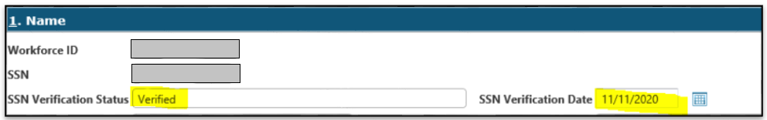
The following may appear in this field.
  - Verified – SSA has confirmed that the name, SSN and date of birth for the consumer in AWARE™ matches their records. If our information is correct, SSA also provides a response regarding any benefits this individual is receiving and those results are included in Section 5: “Financial” on the Intake page in AWARE™ (discussed later).
  - Not Verified – SSA was unable to give us a response due to an error we have in the system; more work needs to be done. Social Security Programs Unit handles these cases and will reach out via email for more information and case note any findings.
  - Blank – The batch process has not yet been run and results have not been imported into AWARE™. Counselor will need to check back later. A good rule of thumb is to check back 10 days after the intake page was created.
- A new field: SSA Benefits Verification Date (not editable) was added and is auto-populated with the date in which the SSA response data was obtained:
This field will remain blank until the batch process is complete.

AWARE Intake Screen: Section 5 (Financial)
Counselors/administrative staff are still able to select SSDI Status and SSI Status on the dropdowns as well as enter dollar amounts into the boxes next to benefit type. These fields as well as additional new fields, will be updated once a verified response is returned by the batch process.
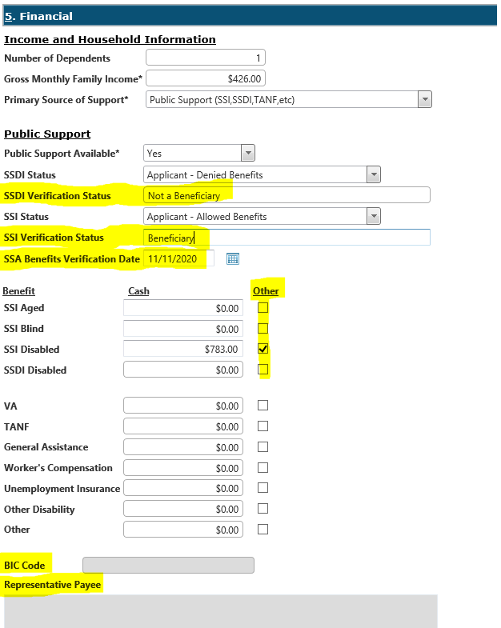
Below each dropdown you will find new non-editable fields entitled “SSDI Verification Status” and “SSI Verification Status” as well as “SSA Benefits Verification Date.” These fields will be populated by the batch process and will indicate whether the individual is a “Beneficiary” or “Not a Beneficiary” for a specific type of benefit as well as show the date when these results were made available by SVES.
Further down in the financial section, you will see the Benefit type, Cash amount, and Other checkbox.
- SSI Disabled and SSDI Disabled fields will automatically populate an amount if SSA has provided that information. Due to limitations in AWARE™ and in the SVES process, the system cannot distinguish between SSI types and between SSDI and other Title II benefits (such as retirement, survivor’s benefits, etc.). Social Security Programs Unit staff will be providing clarification in specific instances, but a good rule of thumb is that if the individual is over age 65 and the system indicates an SSI amount, then this is SSI aged. If the individual is over age 67 and receiving SSDI, then this is likely retirement (if between 65 and 67 then this may be retirement based on the retirement age calculator).
IMPORTANT NOTE: For consistency with the batch process, if a consumer indicates they receive a dollar amount for SSI, only enter that amount in the SSI DISABLED box.
- “Other” checkbox. If the box is checked please:
  - Check the age of the individual. If over 65 (or 67) as described above, then this amount is likely tied to retirement or aged benefits. Retirement and aged benefits, alone, do not meet the criteria for presumption, but the individual may be receiving other cash or needs based benefits which would.
  - If not over age 65 (or 67) check your case notes. The case note will explain the benefits your consumer is likely receiving, such as survivor’s benefits, etc., which may or may not meet criteria for presumption of eligibility.
  - Inquire of the consumer if they can provide a copy of their most recent benefit letter from Social Security. This is the best way to confirm the type of benefit if presumption of eligibility is in question.
- BIC Code (not editable) Beneficiary Information Code – This field will most likely always remain blank and you do not need to use this in any way, it was left in AWARE™ by Alliance.
- Representative Payee (not editable) – If provided by SSA, this field includes information about a consumer’s representative payee, responsible for managing their benefits. The Rep Payee should be included in benefits planning services. Due to character limitations and formatting in SVES, the entire name of the payee may not be available. SVES shows the first five characters of first name, then the middle initial, then the last name. There will be no spaces between the names. Coordination with the consumer to clarify the representative payee may be necessary.

Next Steps
There will typically be three types of work to do once a batch verification has been completed and verified based upon the intake screen and case notes or emails from Social Security Programs Unit staff.
- No case note and no email – The batch process completed successfully and the benefit status of the consumer is clear.
- Benefits amount, type, and “Beneficiary” are clearly indicated on the intake screen. Counselors may proceed with eligibility, order of selection, and case services (such as benefits planning as appropriate).
- No benefits type or amount are provided and “Not a beneficiary” is listed in the SSDI and SSI Benefits status fields. This indicates that the individual is not receiving disability benefits, benefits planning would not be required, and the counselor can proceed with next steps in their case.
- Case note and no email – The batch process completed successfully but a minor change was made or is being monitored.
- Counselors will receive a case note; however, they don’t have to follow up with anything further and so will not receive an email. Counselors may note the change the next time they are actively in the AWARE™ case. Examples of this include the correction of a date of birth or situations where the individual has an application for benefits pending but has not yet been allowed benefits (in those cases Social Security Programs will continue to monitor the case and then email if a change is made in the future).
- Case note and Email – The process may or may not be complete. Further work is needed.
- Counselors will receive a case note and email regarding the circumstances in which the counselor will need to make a change or reach out the consumer to correct an error. Examples of situations that may require a case note and email to the counselor include: an incorrect SSN, an incorrect spelling, SVES indication that the consumer is deceased, or if SSA indicates an issue that may require the consumer contact SSA (such as suspended benefits due to a change of address, not providing updated forms, etc.).

Navigating Away From The Intake Screen
Once the batch process has been completed for a consumer, the next time a counselor accesses the intake screen, they may need to update certain fields or will receive an error when attempting to leave the screen. Two examples:
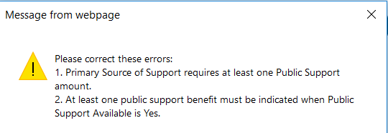
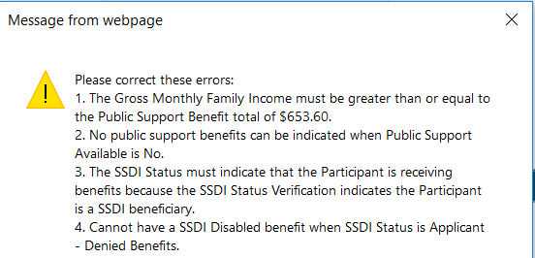

The text in the error box will tell you what needs to be corrected. These are usually very simple corrections such as updating amount totals or selecting the appropriate type of support from the dropdown menu.
It’s not critical to drop what you’re doing and go through every case immediately to correct the intake page, but as you are in the case please complete the prompt after “finishing” the intake page.
Note: If you are working with an open case Eligible status or beyond, please be advised that a “clean-up” process has begun that may make changes to information on the Intake page. Counselors should not make changes to any SSI/SSDI status drop down options in AWARE™ after Intake page has been initially completed. Please review case notes for Program Income details of changes made through the SVES automated process.

A Note about Medical Insurance (Medicare/Medicaid)
In general, if an individual is receiving SSDI or another type of Title II benefit, they will most likely be receiving Medicare. If an individual is receiving SSI (Title XVI benefits of any type), they will most likely be receiving Medicaid. Occasionally, individuals receive both types of cash benefits and health insurances. Further, there are also other ways to access these benefits, so it is best to confirm with the consumer as to what type(s) they receive.
INQUIRIES:
- Eric Schmidt (eric.schmidt@maryland.gov) 410-554-9295
- Kyle Beeson (kyle.beeson@maryland.gov) 410-554-9547

